Mockito Mock Dependencies Exercises

Name: Shubham Sangram Bej

Aim
To understand and implement Mockito-based testing in Spring Boot applications by mocking dependencies, testing REST controllers using MockMvc, and performing integration testing with the H2 in-memory database.

Objectives
- Understand the concept of mocking in unit testing.
- Learn to use Mockito for testing service layer dependencies.
- Test REST controllers using MockMvc.
- Perform integration testing in Spring Boot.
- Validate repository interactions using H2 Database.
- Improve application quality through automated testing.

Software Requirements
- Java JDK 21
- IntelliJ IDEA 2026
- Apache Maven
- Spring Boot 3.5.16
- Spring Web
- Spring Data JPA
- H2 Database
- Mockito
- JUnit 5
- MockMvc
- Git
- GitHub

Theory
Mockito is a popular Java testing framework used to create mock objects for unit testing. It allows developers to isolate a class by replacing its dependencies with mock implementations, making tests independent of databases or external services. Spring Boot integrates Mockito with JUnit 5 to simplify testing of service classes, REST controllers, and application components. MockMvc enables testing of web controllers without deploying the application, while H2 provides an in-memory database for integration testing.

Advantages
- Simplifies unit testing by mocking dependencies.
- Reduces dependency on external resources.
- Improves application reliability.
- Enables faster execution of test cases.
- Supports REST API testing without starting a server.
- Provides better code maintainability.
- Encourages Test-Driven Development (TDD).
- Increases confidence during application development.

Exercises Performed

Exercise 1 – Mocking Repository Dependency Using Mockito

Description
A UserRepository was mocked using Mockito, and a UserService was tested independently. Repository responses were stubbed using Mockito, and the returned user object was verified using JUnit assertions.

Result
The service layer correctly returned the mocked user object, and the test case executed successfully.
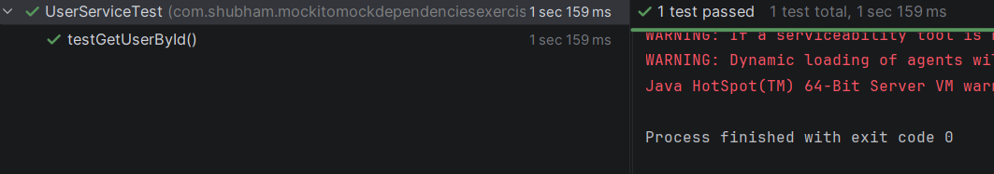

Exercise 2 – Mocking Controller Dependency Using MockMvc

Description
A REST controller was created to expose a GET endpoint for retrieving user information. The controller was tested using MockMvc while mocking the service layer. The JSON response and HTTP status code were verified.

Result
The controller returned the expected JSON response, and the endpoint test passed successfully.
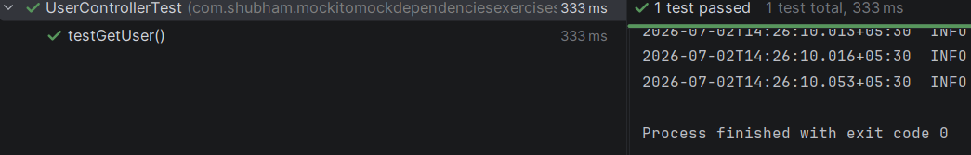

Exercise 3 – Integration Testing Using Spring Boot

Description
An integration test was performed using the H2 in-memory database. User data was stored and retrieved using the repository to verify end-to-end interaction between the application components.

Result
The integration test successfully saved and retrieved user information from the H2 database.
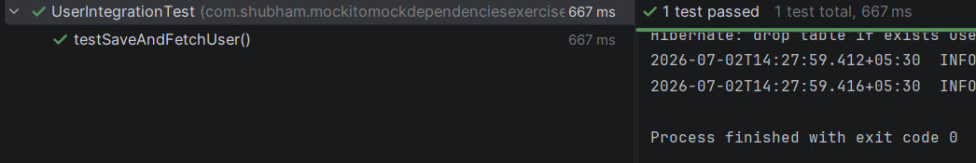

Project Structure
MockitoMockDependenciesExercises
│
├── src
│ ├── main
│ │ ├── java
│ │ │ └── com.shubham.mockitomockdependenciesexercises
│ │ │ ├── controller
│ │ │ ├── entity
│ │ │ ├── repository
│ │ │ ├── service
│ │ │ └── MockitoMockDependenciesExercisesApplication.java
│ │ │
│ │ └── resources
│ │ └── application.properties
│ │
│ └── test
│ └── java
│ └── com.shubham.mockitomockdependenciesexercises
│ ├── controller
│ │ └── UserControllerTest.java
│ ├── service
│ │ └── UserServiceTest.java
│ └── UserIntegrationTest.java
│
├── screenshots
├── README.md
└── pom.xml

Results
The following tasks were successfully completed:
- Created the Spring Boot project using Maven.
- Implemented the User entity, repository, service, and controller.
- Performed unit testing using Mockito.
- Tested REST controller endpoints using MockMvc.
- Executed integration testing using the H2 in-memory database.
- Verified all test cases using JUnit 5.
- Successfully completed all exercises with passing test cases.

Conclusion
The Mockito Mock Dependencies Exercises provided practical experience in testing Spring Boot applications using Mockito, JUnit 5, MockMvc, and Spring Boot Test. The project demonstrated how to isolate dependencies using mock objects, test REST controllers effectively, and perform integration testing with an in-memory database. These exercises strengthened the understanding of automated testing practices and highlighted the importance of writing reliable and maintainable test cases in enterprise Java applications.

References
- Spring Boot Documentation – https://spring.io/projects/spring-boot
- Mockito Documentation – https://site.mockito.org/
- JUnit 5 User Guide – https://junit.org/junit5/docs/current/user-guide/
- Spring Framework Documentation – https://docs.spring.io/spring-framework/reference/
- Apache Maven Documentation – https://maven.apache.org/

